How to Find Student Information

- Go to My Grizzly Den and enter your BearPass Login and password.
- Click the Teaching and Advising tab.
- On the Advisor Resources Channel, choose ID Selection.
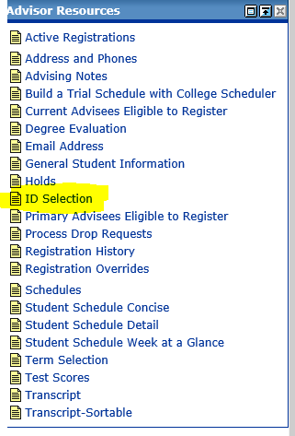
- Select the appropriate term click Submit.
- On the Student and Advisee ID Selection screen under Student and Advisee Query, enter the Last Name and First Name of the student. This information is not case sensitive and you may list only a partial name. For this search, select All, and then click the Submit button.

Explanation of Search Types
  - Students: only searches for students in your courses.
  - Advisees: only search for students on your advisee list.
  - Both: searches for students in your courses and on your advisee list.
  - All: searches for all students in database.
- Choose the appropriate student from the drop-down list and click Submit.
- You are taken back to the Student Information menu. Any selections you make from here will now relate to the selected student.
- Select the appropriate term click Submit.
- On the Student and Advisee ID Selection screen under Student and Advisee Query, enter the Last Name and First Name of the student. This information is not case sensitive and you may list only a partial name. For this search, select All, and then click the Submit button.

Explanation of Search Types
  - Students: only searches for students in your courses.
  - Advisees: only search for students on your advisee list.
  - Both: searches for students in your courses and on your advisee list.
  - All: searches for all students in database.
- Choose the appropriate student from the drop-down list and click Submit.
- You are taken back to the Student Information menu. Any selections you make from here will now relate to the selected student.

