How to Activate Your Missouri State Account
In order to access University resources, you need a Missouri State account. To activate your account, you will need your M-Number and Activation Code.
If you do not know your Activation Code, please see I don't know my Activation Code.
Step-by-step guide
- Go to the Account Management page.
- Select the Activate Your account.
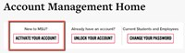
- Enter your M-Number.
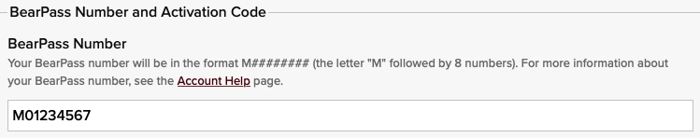
- Enter your Activation Code.
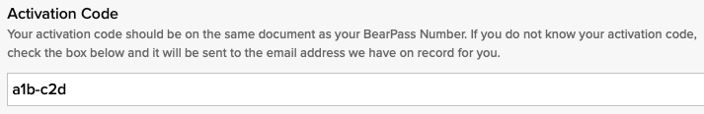
Please Note: If you don't know your Activation Code, you can select the check box next to I don't know my Activation Code and the code will be emailed to the address we have on file for you. See more below at I don't know my Activation Code.
- Click Submit.
- You will see your Missouri State Account and Account ID listed at the top of the page. This will typically be your initials followed by 1-4 numbers, and it will have an "s" at the end if you are a student or an "e" if you are an employee. This will be your ID/username for a variety of University systems.
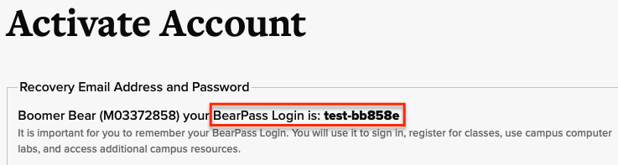
- Enter and confirm a Recovery Email Address. This cannot be a Missouri State email address.
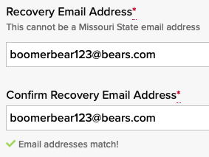
- Create and confirm your Missouri State Password. See Missouri State Account Password Requirements for creating a secure password.
- Your account has been successfully activated. You will receive an email confirming your account was successfully activated. It will take up to 30 minutes before you can log into any resources using your Missouri State Account.
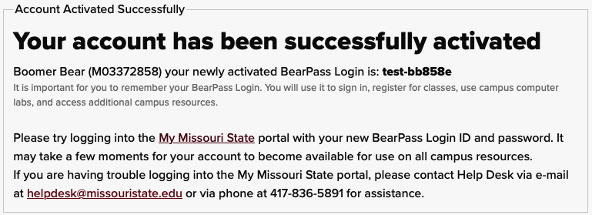
- Once your account is available, see the instructions for How to Set Up Your Account Security Information to help you reset your password or unlock your account in the future.

I don't know my Activation Code
- If you don't know your Activation Code, you can select the check box next to I don't know my Activation Code and the code will be emailed to the address we have on file for you.
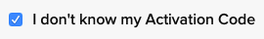
- If you don't have an email address on file or you don't recognize the email address listed, contact the office listed below (The image below is an example showing where to look for the email address the code was sent to and which department to call. You will see different contact information depending on your status and department).
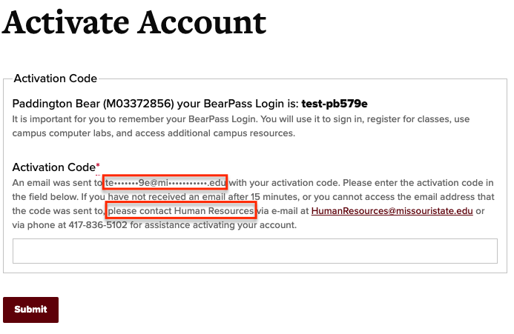
- If you are unable to request your Activation Code via email in the steps above, you have the following options:
- If you are a student, contact the department who admitted you. This information should be listed in your admission packet.
- If you are an employee, contact Human Resources at 417-836-5102 or HumanResources@MissouriState.edu.

