How to Enter Grades in Faculty Grade Entry

Instructions for Grading
If at any point you have questions during the grading process, you are welcome to contact the Office of the Registration & Records: 417-255-7979 or WPRR@missouristate.edu
  - Go to My Grizzly Den and enter your BearPass Login and password into the appropriate fields.
You will only have access to assign grades to students enrolled in the classes for which you are the instructor of record.
  - Along the top of the My Missouri State main menu click the Teaching & Advising tab.
  - From the Faculty Grade Assignment channel click the Final Grades link.
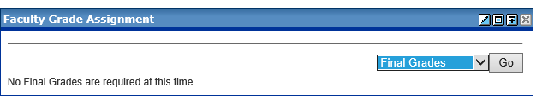
  - Make sure the appropriate grading tab (Midterm Grades or Final Grades) is selected.
The Faculty Grade Entry system will default to the Final Grades tab. If this is a midterm grading cycle, you will need to click on the Midterm Grades tab in order to begin grading.
  - Click on the course to begin grading.
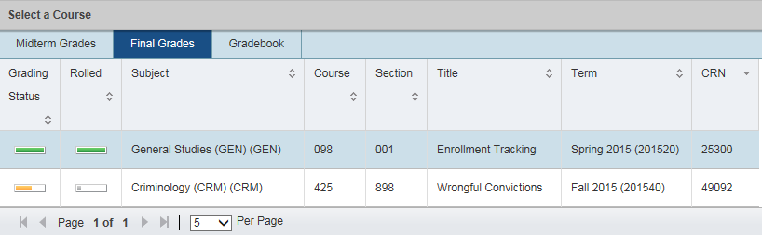
  - To assign a grade for each student in the list, select the grade from the drop down menu or type in the grade.
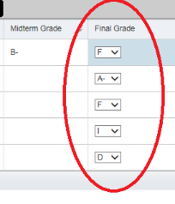

- If you assign a grade of 'F' you MUST do one the following:
- If the student never attended class, enter the first day of the class by clicking on the Last Attend Date field and select the date from the calendar icon.
- If the student attended part of the semester then quit attending and has not returned, enter the date of last attendance in the Last Attend Date field. If you do not know the exact date, provide your best estimate. If the class is an online class, check to see when the student last submitted an assignment, used the discussion board, or emailed. If none of these records can be found, it can be assumed that the student never attended.
- If the student finished the class, enter the last date of your class in the Last Attend Date field.
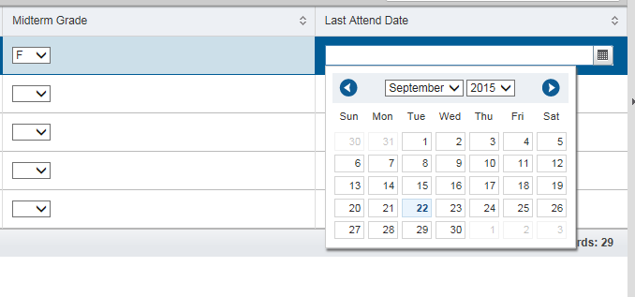
- When the grades have been entered, click Save at the bottom of the page.
- After saving, the notification window in the upper right-hand corner, will warn you when there is an error to check.
- Please make sure you log out of the system.

