Welcome to Missouri State University West Plains
This document will guide you through what to expect as you prepare for your first semester at MSU-WP. On the digital version of this document click on the blue links to watch the videos.

Before you can do anything on this list you need to have your acceptance letter from the admissions office. In this letter you will find:
- Missouri State Student Number which is called your M Number
- Activation Code- This will let you into My Grizzly Den
- Explore MyGriz Den
  - This is where you can find any school information
    - Registration for classes
    - Financial Aid
    - Email shortcut
    - Brightspace shortcut
- School Email
o The college staff/faculty will only email your school email, not your personal email
o Check your email at least weekly before you come to campus
- You can check your email through MyGrizzlyDen
- Add your email account to your phone so you can check more easily
- Answer any emails that need a response
- Delete emails or add folders in your email account to organize information you may need later
- IT Support
  - Lybyer Technology Help Desk-417-255-7995
  - Check out the IT support brochure in this packet.

- Things to work on now...
  - Contact the Financial Aid Office-417-255-7243
    - Complete the FAFSA Application
    - Apply for MSU-WP scholarships
  - Think about signing up for disability services- Pam Tate- 417-255-8062 or 417-547-7573
    - This is on MSU-WP campus and is how you get accommodation in your classes.
  - Sign up with Missouri Vocational Rehab- This may help with tuition, books and supplies. Angie Nicholson- 417-256-8294
  - Call to set up an appointment with an advisor- 417-255-7222
    - Make sure to register for classes
    - Sign up for Star Orientation
      - May 22, Aug. 2, Aug. 9, Aug. 14 all the meetings are at 10 AM
  - If you want to live on campus, you must apply - 417-255-8020

Helpful Account Terminology
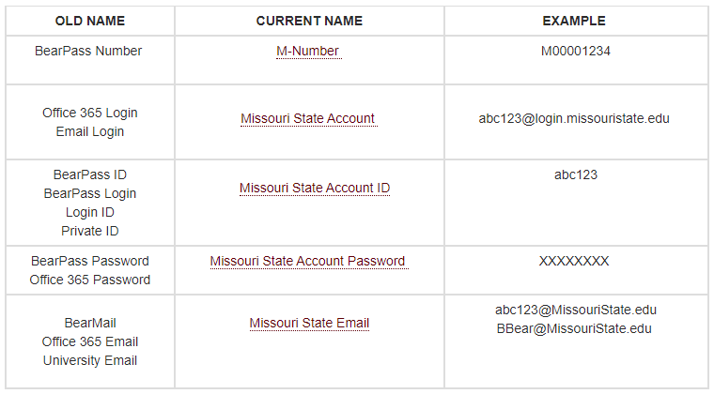
Got Questions? Feel free to contact the ASCEND Staff
Mikala King- Program Director, mikalaking@missouristate.edu 417-255-7722
Tanya Miller- Support Coordinator, tanyamiller@missouristate.edu 417-255-7275
Christina Hodgson- Administrative Assistant, chodgson@missouristate.edu 417-255-7711

