How to Print a Course Roster
Go to mygrizzlyden.missouristate.edu website
Log in
Click on “My Teaching/Advising” tab
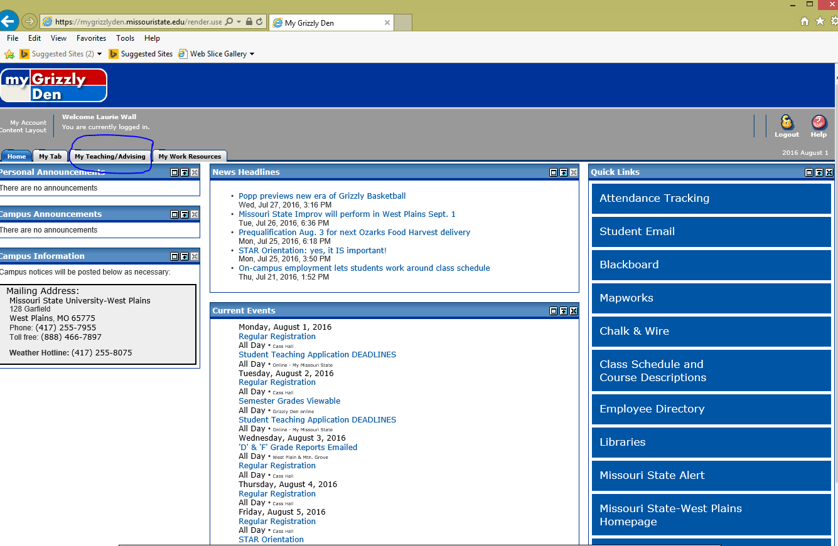
Click on the course you need roster for under “Faculty Dashboard”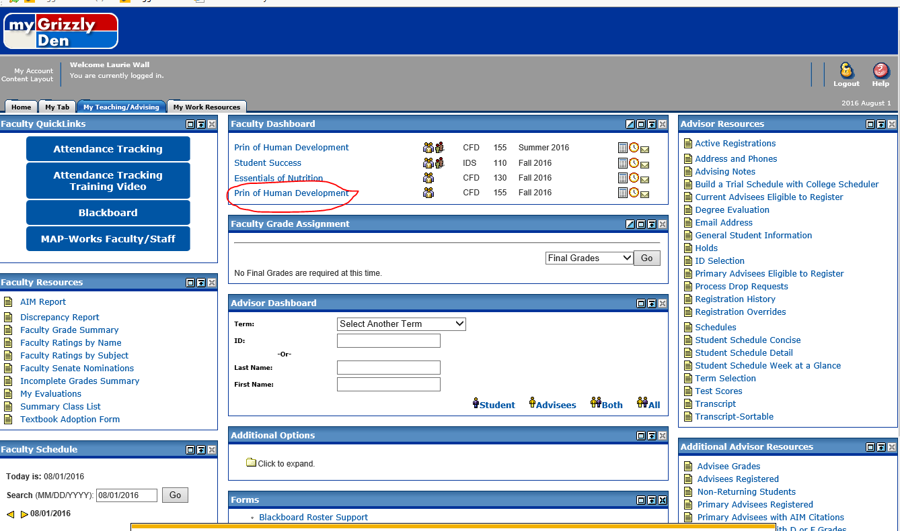
Click on “Classlist”
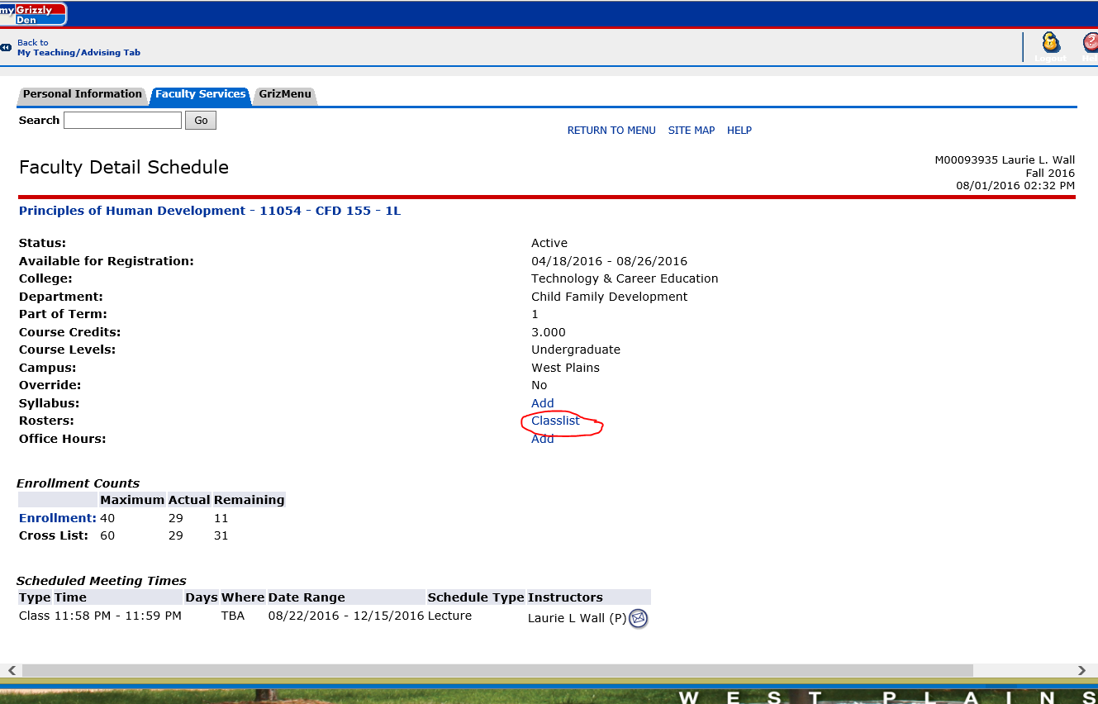
Click on the cog and print, Control P or File, Print.