TASK D (TUBERCULIN SKIN TEST)
- Obtain a TB Skin Test (see Health Department contacts) The TB risk assessment form does NOT meet this requirement or
- Obtain a Chest X-Ray verifying negative TB status or
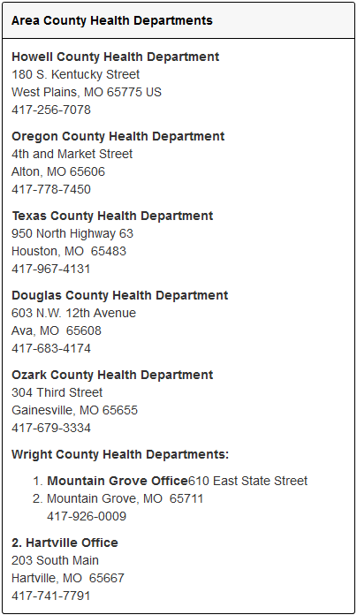
- If pregnant submit a doctor's note indicating inability to obtain TB Skin Test

